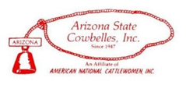

January 28, 2022

ANCW INCOMING PRESIDENT PAM GRIFFIN
BRAND QUILT FUNDRAISER

TO ALL THE FRIENDS OF ARIZONA’S CATTLEWOMAN PAM GRIFFIN

We are so proud of Arizona’s ranch woman and Cowbelle Pam Griffin of Globe, Arizona for being elected as the American National CattleWomen (ANCW) Vice President. Pam will be installed as the next ANCW President in January 2023.

To defray some of the substantial expenses that Pam will incur while she is the ANCW President, our Arizona State Cowbelles are fundraising! In addition to helping with Pam’s ANCW expenses, this fundraiser will also result in a beautiful hand-sewn quilt, providing lasting memories of all the extraordinary friends and supporters Pam has met during her many years promoting and serving the Beef Industry. This quilt will be presented to Pam at her installation in 2023.

For Pam’s fundraiser the Arizona State Cowbelles invite you to submit an image of your registered brand which will be used as design squares for this quilt. We also welcome any donations! Each brand will be copied, cut from fabric and sown on fabric squares. These squares will become the design of the quilt. Every brand will represent one of many unique ranching friends and families that Pam has met and worked alongside. Showcasing our ranches’ brands helps all Cattlewomen meet our primary missions: to preserve our long, ranching heritage and to promote our beef industry.

Brand Squares are $75.00 each
We want to sell 100 brand squares which will provide $7,500.00 plus the quilt. A portion (less than $1,000) of the funds will be needed to purchase supplies for the quilt and having it made. Arizona State Cowbelle MaryBeth Groseta of Prescott, AZ has very generously offered to make the quilt for this fundraising project.

It’s simple to help with this fundraiser: just complete the information on Page 2 and very carefully draw your brand in the block provided. If you have a copy of your brand certificate please include also: this allows for an exact copy of your brand. Then, mail a check for $75.00 to support this fundraiser. All donations and brands must be received no later than June 30, 2022. An example of a similar quilt is shown below as an example of our AZ quilters’ talents.
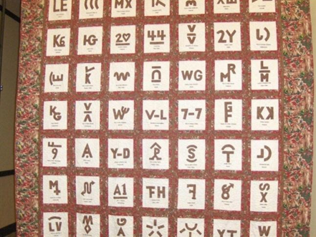
Please consider adding your brand to Pam’s quilt and let her know you helped to support her when she was the ANCW President. The Arizona State Cowbelles thank you so much for your support on this project!

Stephanie Teskey
President
Arizona State Cowbelles

Instructions For Submitting Your Brand For Pam’s Quilt

Please do the following to include your brand on Pam Griffin’s brand quilt:

- DRAW your brand exactly as you wish it to appear on the quilt’s brand square.
- PRINT your name(s) and your ranch’s name as you wish it to appear.
- PRINT your mailing address.
- PRINT the AZ (state) registration number of your brand (if known).
- PRINT your telephone number.
- PRINT your email address.
- INITIAL your brand, to show it is correct as drawn.
- MAIL THIS PAGE (Page 2), along with a check payable to “AZ State Cowbelles” in the amount of $75.00 to one of the Arizona State Cowbelles’ fundraising co-chairs below:

Marie Pyeatt
418 Cimarron Rd
Elgin, AZ 85611

Karla Cafarelli
PO Box 677
Sonoita, AZ 85637

Thank you very much for your support of Pam Griffin!
Your name(s) as it will appear on brand square
Your ranch’s name as it will appear on brand square:
Your mailing address:
AZ brand registration number (if known):
Your telephone number:
Your email address:

Your initials: ________________

Draw brand in this box

